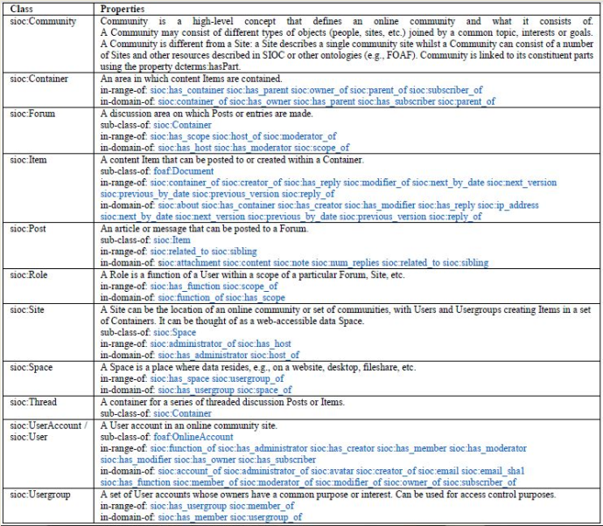**TABLE III. SIOC Classes and Properties**